**Memo: Model for fuel fabrication in EG29**

Baptiste MOUGINOT,

April 29, 2016

**introduction**

This memo is about the difference in the modeling of the Case 1.1 to 1.3 of EG29 study, induced by the use of a Pu-equivalent model for the fuel fabrication. The case 1 of the EG29 calculation correspond to the modeling of single MOX-PWR at steady-state (see figure 1). This case 1 is subdivide in three subcases corresponding respectively:

* 1: calculation without isotopic composition,
* 2: with isotopic composition and no decay,
* 3: with isotopic composition and decay.



Figure 1 Schematic of Pu mass flow for Case 1

**Calculation:**

For each sub-case (1.1 to 1.3), 2 calculations have been done. One using a standard mixing fab/cycamore::mixer, mixing the E3” and the J1” stream using constant mixing ratio to build the MOX fuel for the PWR and will be labelled “M”. The second calculation is using the plutonium equivalent theory to determine the mixing fraction of each stream to build the MOX fuel and labelled “W”.

**Results:**

The difference in the plutonium contribution to build the MOX fuel are shown figure 2. Those contributions are normalized by the tPu/y (as in figure 1). As expected the calculation using the mixer results in a constant contribution of both stream for the first 1.2 cases. The variation observe in the third case is just due to the decay of 241Pu, which contribute after decay as 241Am.

Concerning the calculation using the plutonium equivalent, the case 1.1 reproduce exactly the calculation with the fix mixing ratio. The small discrepancy on case 1.2 is not expected. This is probably due to a rounding discrepancy…

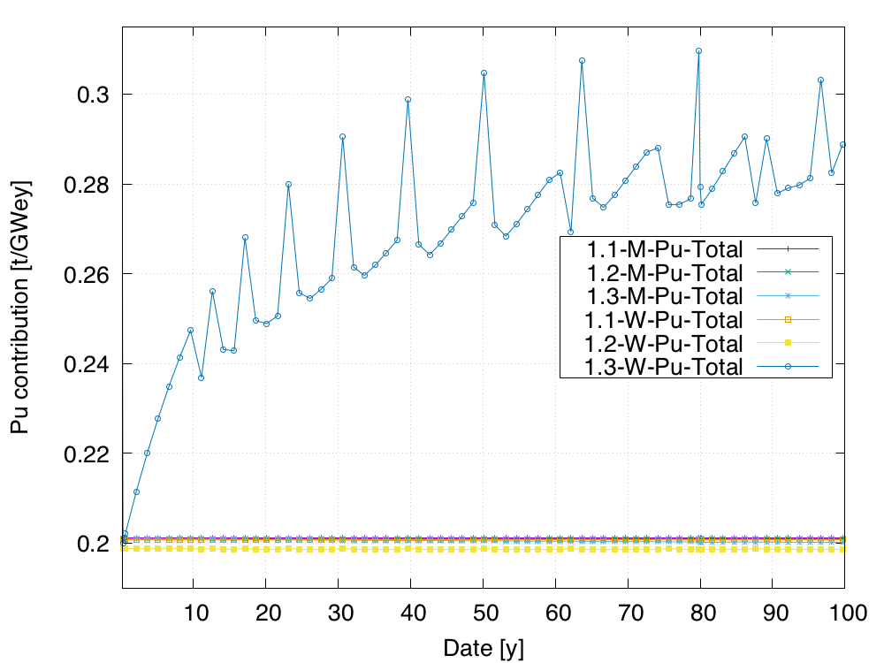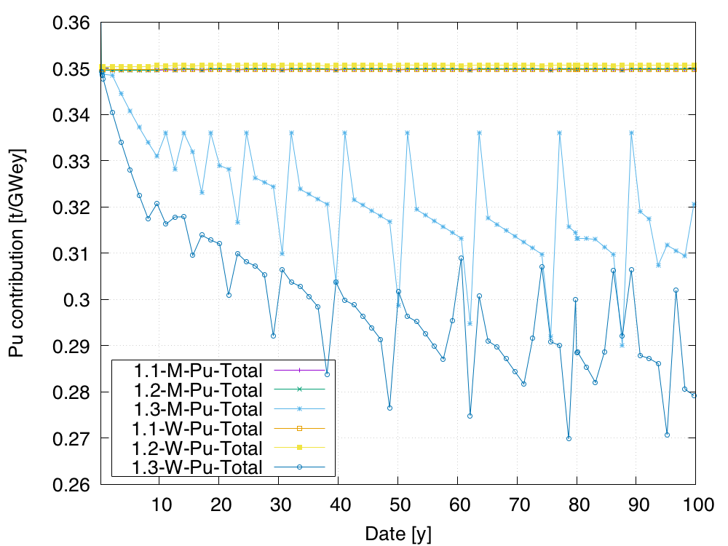

Figure 2 Evolution of Pu contribution on J1” stream (left figure) and E3” stream (right figure)

On Case 1.3, which include isotopic compositions and decay, one can see a much large discrepancy on both calculations. In the fix mixing ratio calculation (M), the only fluctuations are coming from the decay of Pu241 of the stream J1’’. The E3’’ stream containing very few short-living plutonium is not impacted by the decay.

For the calculation using the Pu equivalent model(W), the decay of Pu241 have a large impact on the fabrication of the MOX fuel: as the Pu241 is transmutation in Am241, the plutonium from the J1” stream loose a part of its “reactivity potential”, forcing the increase of E3” stream amount in the mix from 0.210 tPu/y to almost 0.3 tPu/y.

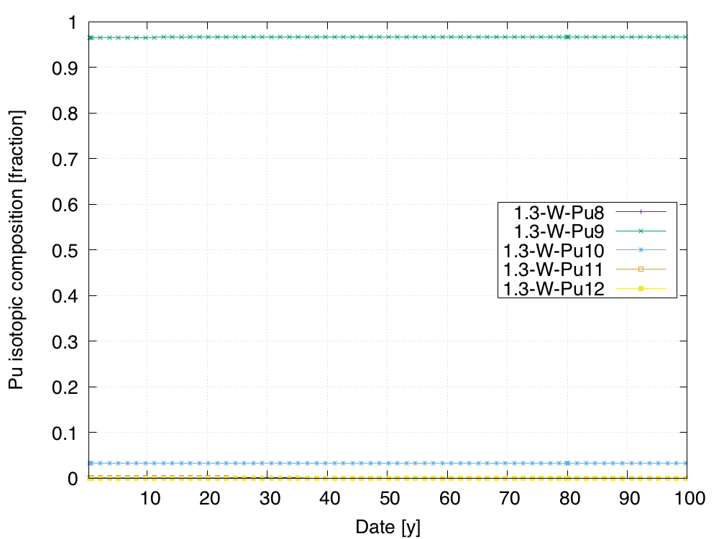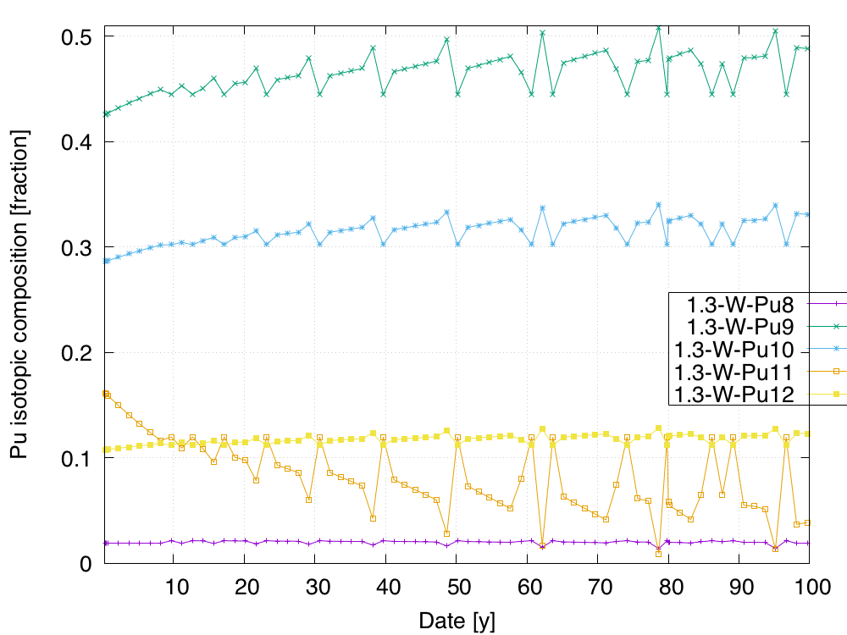

Figure 3 Evolution of the plutonium composition in Case 1.3